PLEASE ANSWER ALL QUESTIONS |  |  | Total 50 Marks
Question 1
 |  | Determine the open intervals on which the function, is increasing or decreasing.
 |  | (5 marks)
Question 2
 |  | Determine the area of the region bounded by the graphs of 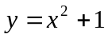and for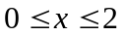. Outline the region bounded by the graphs.
 |  | (6 marks)
Question 3
Calculate the following integrals:
i) 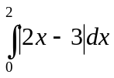
ii) 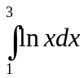
 |  | (8 marks)
Question 4
Compute the following Integrals:
i) 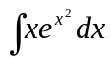

ii) 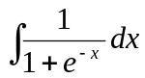
 |  | (8 marks)
Question 5

 | a) | 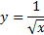  Determine the tangent line to the graph of when x=4. Diagram the line tangent to the graph at x=4.
 |  | (6 marks)
 | b) | Measure all the relative extrema of the function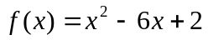.
 |  | (5 marks)
Question 6
 | a) | An evergreen nursery usually sells a type of shrub after 5 years of growth and shaping. The growth rate during those 5 years is approximated by  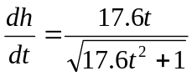  Where t is time in years and h is height in inches. The seedlings are 6 inches when planted (t=0).  - Develop the height function.  - Illustrate how tall the shrubs when they are sold.
 |  | (7 marks)
 | b) | Solve the equation 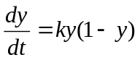to develop a logistic growth model.
 |  | (5 marks)
 |  | **END OF QUESTIONS**

